Social Media Toolkit:
Supporting FDA’s Efforts to Prohibit Menthol Cigarette & Flavored Cigars

In the coming days, the FDA is expected to issue proposed rules to prohibit menthol cigarettes and flavored cigars. Below is a social media toolkit with graphics and draft caption copy to support the FDA’s proposed rules when they are issued. The graphics in this Word doc are for reference and can be downloaded at www.tfk.org/mentholgraphics. This webpage includes images sized for Facebook/Twitter and Instagram. The caption copy is sized for Twitter and tags the FDA’s main Twitter channel (you can also tag @FDATobacco). Please remember to edit/remove the caption tag accordingly for other platforms. Also, please feel free to edit the caption copy as you see fit.

Post #1: Three Reasons Post #2: Impact on Black health
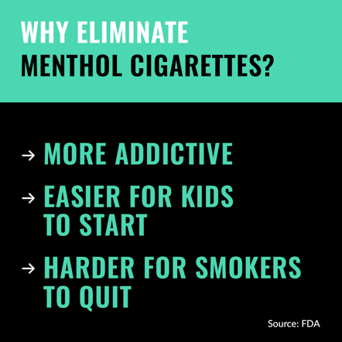
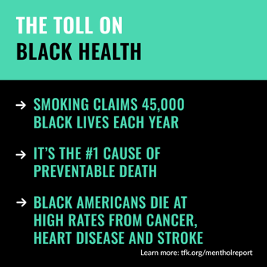
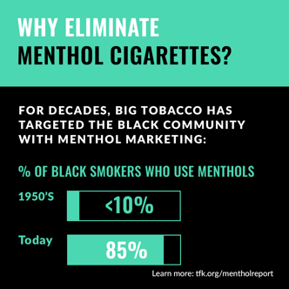

Post #1 copy:
Option A:
Menthol cigarettes cause great harm to public health. Menthol masks the harshness of smoking, making it easier for kids to start and harder for smokers to quit. That’s why we support @US_FDA’s efforts to get rid of menthol cigarettes.

Option B:
Big Tobacco has long targeted kids, Black Americans, the LGBTQ+ community and other groups with menthol cigarettes, putting profits before lives. We strongly support @US_FDA’s efforts to eliminate menthol cigarettes to protect kids and save lives.

Post #2 copy:
Option A:
For decades, the tobacco industry has targeted the Black community with menthol cigarettes, and @US_FDA is finally taking action to stop this devastating cycle by eliminating menthol cigarettes. We fully support this historic step to save Black lives.

Option B:
Big Tobacco’s targeted marketing of menthol cigarettes has had a devastating impact on Black health and lives. We strongly support @US_FDA’s efforts to get rid of menthol cigarettes and put an end to this cycle of addiction, disease and death.
Post #3: Impact on Kids
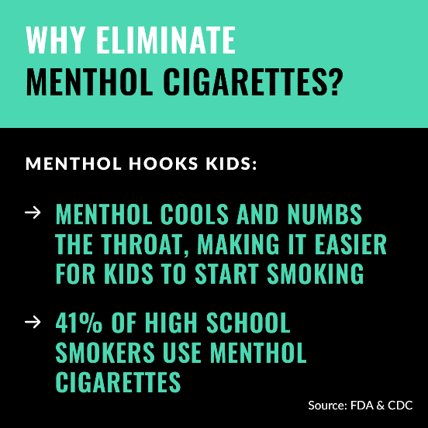

Post #3 copy:
Option A:
Tobacco companies can’t survive if kids don’t smoke. Menthol helps them hook kids by masking the harshness of smoking and making it easier for kids to start. We strongly support @US_FDA's efforts to eliminate menthol cigarettes.

Option B:
We strongly support @US_FDA’s efforts to eliminate menthol cigarettes and protect future generations from addiction. Menthol makes the harshness of smoking, making it easier for kids to start and ultimately get addicted. It’s time to get rid of them.

Other posts on menthol cigarettes/flavored cigars

We strongly support @US_FDA’s proposed rules to eliminate menthol cigarettes and flavored cigars. It’s time to stop tobacco companies from using these flavored products to hook kids, Black Americans and other groups.

By issuing proposed rules to eliminate menthol cigarettes and flavored cigars, @US_FDA is taking bold action to protect kids, advance health equity and save lives, especially among Black Americans. We urge FDA to finalize and implement these rules without delay.

The FDA’s proposed rule to eliminate flavored cigars will protect kids from tobacco addiction, especially Black youth. The tobacco industry targets kids with cheap, small cigars sold in a variety of sweet flavors. Enough is enough.

Blue Raspberry. Mango. Tropical Twist. Wild Rush. These are just a few in an endless list of cigar flavors. There’s no question who these flavors are targeting: kids. We fully support the @US_FDA’s proposed rule to get rid of these products for good.

